ECA0304 – SIGNALS AND SYSTEMS
CO1 CONCEPTUAL LEARNING ASSESSMENT
MAKING AN AUTONOMOUS DELIVERY VEHICLE RELIABLE
Signal and System Analysis of a Smart Mobility Controller

Submission detail | Information
Course | ECA0304 – Signals and Systems
Course Outcome | CO1 – Conceptual learning
Assessment | Four-stage engineering analysis
Total marks | 100
Student name | K. Shalini
Register number | 192512270
Department / Section | B.E.ECE

CONTENTS
- 1. Introduction and Engineering Problem
- 2. Stage 1 – Interpret the Signals
- 3. Stage 2 – Reconstruct the Observed Signal
- 4. Stage 3 – Energy and Power Signal Evaluation
- 5. Stage 4 – Evaluate the Processing Blocks
- 6. Final Engineering Decision and Redesign
- 7. Conclusion
- 8. Formula Summary and Assumptions

1. INTRODUCTION AND ENGINEERING PROBLEM
An autonomous delivery vehicle operating inside a smart industrial campus receives information from a wearable safety monitor, wireless communication unit, IoT proximity sensor, digital logger, emergency trigger, vehicle speed command and synchronization pulse. A real-time controller processes these signals and decides whether the vehicle should move, stop, slow down or communicate with the control centre.
The purpose of this assignment is to classify the observed signals, express them using elementary signals, reconstruct a received pulse through signal operations, distinguish energy and power signals, and evaluate the proposed processing blocks for causality, time-invariance, linearity and BIBO stability.
The analysis follows the required sequence: OBSERVE → CLASSIFY → REPRESENT → TRANSFORM → ANALYZE → EVALUATE → VERIFY → DECIDE.

1.1 Notation used
Notation | Meaning
u(t) | Continuous-time unit-step signal: 0 for t<0 and 1 for t≥0.
u[n] | Discrete-time unit-step sequence: 0 for n<0 and 1 for n≥0.
δ(t) | Continuous-time Dirac delta impulse.
r(t)=t u(t) | Continuous-time unit-ramp signal.
E | Signal energy.
P | Time-average signal power.

2. STAGE 1 – INTERPRET THE SIGNALS
A signal is a function that carries information about a physical phenomenon. Classification is based on whether time is continuous or discrete, whether amplitude is continuous or quantized, periodicity, predictability, symmetry and energy/power behaviour. Only attributes supported by the supplied observations are assigned below.

2.1 Signal classification and representation table
ID | Observed behaviour | Classification | Representation | Engineering justification
S1 | Two very short ECG-like events at t=0.4 s and 0.9 s. | Continuous-time, real-valued physiological waveform; aperiodic event sequence; finite-duration in practice; can be idealized by impulses when only event timing/area is important. | x₁(t) ≈ A₁δ(t−0.4)+A₂δ(t−0.9) | The events are short compared with the observation interval. An impulse model simplifies event timing, but a real ECG pulse has finite width and morphology.
S2 | 4cos(2π·2.4×10⁹t) V across a 1 Ω reference load. | Continuous-time, analog, deterministic, periodic sinusoid; even about t=0; power signal. | x₂(t)=4cos(2π·2.4×10⁹t) | A sustained sinusoid has finite non-zero average power and infinite total energy over infinite time.
S3 | Zero before detection; then 5e^(−3t) V. | Continuous-time, analog, deterministic, right-sided and aperiodic decaying exponential; energy signal. | x₃(t)=5e^(−3t)u(t) | It begins at detection and decays to zero. Its squared magnitude has a finite integral.
S4 | Zero for n<0, then (0.6)ⁿ for n≥0. | Discrete-time sequence, deterministic, right-sided, aperiodic decaying exponential; energy sequence. | x₄[n]=(0.6)ⁿu[n] | The sequence exists only for non-negative sample indices and decays geometrically.
S5 | Emergency trigger: 6δ(3t−6). | Continuous-time impulse signal, located at t=2 s; generalized signal representation. | x₅(t)=2δ(t−2) | The delta scaling property changes the impulse weight by the reciprocal of the absolute scale factor.
S6 | Zero initially, rises linearly, then stays constant. | Continuous-time ramp-limited/saturated command; deterministic and non-periodic for the described behaviour. | x₆(t)=m[r(t)−r(t−T)] | The difference of two shifted ramps creates a rising ramp up to T and a constant value mT afterwards.
S7 | q(t)=u(t)−u(t−4); received pulse has twice amplitude, later start and shorter duration. | Continuous-time rectangular pulse; deterministic, finite-duration and aperiodic; received version is amplitude-scaled, delayed and time-compressed. | q(t)=u(t)−u(t−4); y(t)=2q(a(t−t₀)), a>1, t₀>0 | The time-compression factor a makes the pulse duration 4/a; the delay t₀ moves its start later.

2.2 Elementary signals involved
- S3: A unit-step signal u(t) gates a decaying exponential 5e^(−3t). The step ensures that the signal is zero before t=0.
- S4: A discrete-time unit-step u[n] gates the geometric sequence (0.6)ⁿ.
- S5: The Dirac delta impulse δ(t) represents an ideal event concentrated at one instant.
- S6: The ramp r(t)=t u(t), shifted ramp r(t−T), and their difference represent a ramp that saturates.
- S7: The rectangular pulse is formed by subtracting a delayed unit step from a unit step: q(t)=u(t)−u(t−4).

2.3 Minimum elementary-signal representation of S6
Let m be the ramp slope and T be the instant at which the command stops increasing. The command is zero for t<0, equals mt for 0≤t<T, and remains at mT for t≥T.
x₆(t) = m r(t) − m r(t−T)
x₆(t) = mt u(t) − m(t−T)u(t−T)
For 0≤t<T, the second term is zero and x₆(t)=mt. For t≥T, x₆(t)=mt−m(t−T)=mT. This verifies the required ramp-then-constant shape.
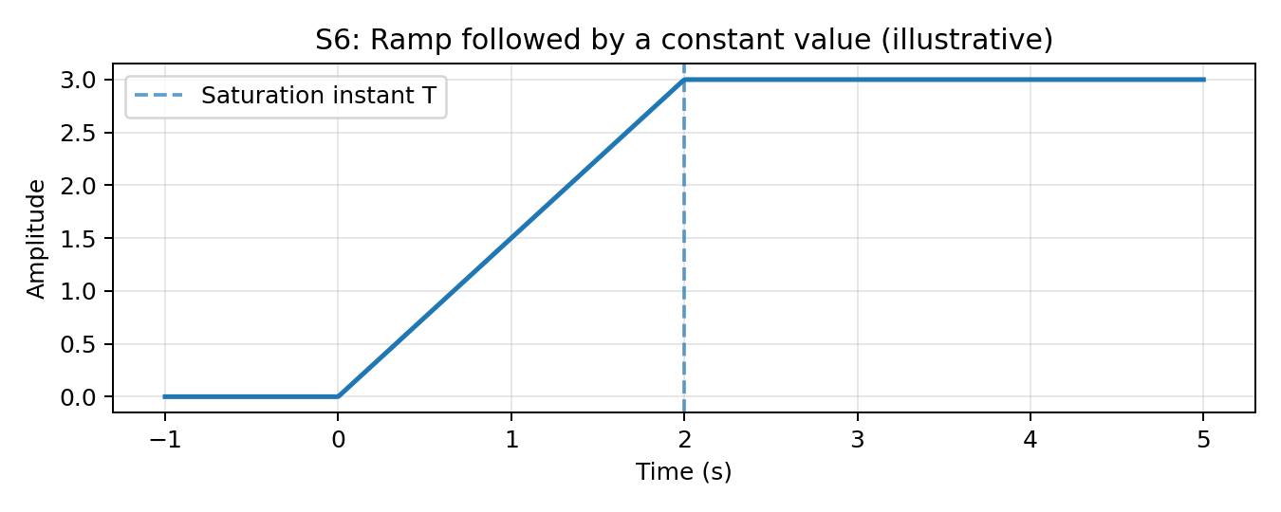
Figure 1. Illustrative ramp-limited command (T=2 s and m=1.5 are example values, not values specified in the question).

2.4 Why S1 and S5 need special treatment
The two ECG-like events in S1 are short compared with the observation interval. If the analysis is mainly concerned with event timing and total pulse area, each event may be approximated by a weighted Dirac impulse. This idealization avoids tracking a very narrow waveform in detail. However, if ECG shape, width, peak amplitude or clinical morphology is important, the actual finite-duration waveform must be retained.
S5 is explicitly written using a Dirac delta. It is an ideal mathematical impulse, not an ordinary finite-amplitude pulse. Its key property is its area (weight), rather than a finite peak value.

2.5 Application relevance
Signal | Application relevance
S1 | Wearable health monitoring: event timing and detection can be analysed using pulse/impulse models, while detailed ECG interpretation requires the actual waveform.
S2 | Wireless communication: a periodic carrier transports information and is naturally analysed using frequency and average power.
S3 | IoT proximity sensing: the decaying response models a sensor output that fades after obstacle detection; its energy affects the sensor's signal budget.
S4 | Digital logging: discrete-time samples are stored and processed by digital controllers.
S5 | Emergency event: an impulse model captures the occurrence time and idealized event strength.
S6 | Vehicle control: a ramp-limited command avoids an indefinitely increasing speed reference.
S7 | Synchronization: pulse amplitude, timing and width help identify alignment between transmitter and receiver.

3. STAGE 2 – RECONSTRUCT THE OBSERVED SIGNAL (25 MARKS)

3.1 Signal-operation sequence for S7
The reference pulse is q(t)=u(t)−u(t−4). It has amplitude 1 and is non-zero over 0≤t<4. The received pulse is described as having twice the amplitude, starting later and occupying a shorter interval. These observations imply amplitude scaling, time compression and a positive time delay.
- Start with the reference: q(t)=u(t)−u(t−4).
- Compress the pulse in time by a factor a>1: q(at). Its duration changes from 4 to 4/a.
- Double its amplitude: 2q(at). Its amplitude changes from 1 to 2.
- Delay it by t₀>0: y(t)=2q(a(t−t₀)). The pulse now begins at t=t₀.
y(t) = 2[u(a(t−t₀)) − u(a(t−t₀)−4)]
Since a>0, the received pulse is equal to 2 for t₀≤t<t₀+4/a and zero elsewhere. Its start is later than the reference start, its duration is shorter than 4, and its amplitude is twice the reference amplitude.
Operation | Mathematical form | Effect
Reference | q(t) | Amplitude 1; duration 4; starts at 0.
Time compression | q(at), a>1 | Duration becomes 4/a; start remains 0 before delay.
Amplitude scaling | 2q(at) | Amplitude becomes 2; duration unchanged.
Time delay | 2q(a(t−t₀)), t₀>0 | Start moves to t₀; duration remains 4/a.

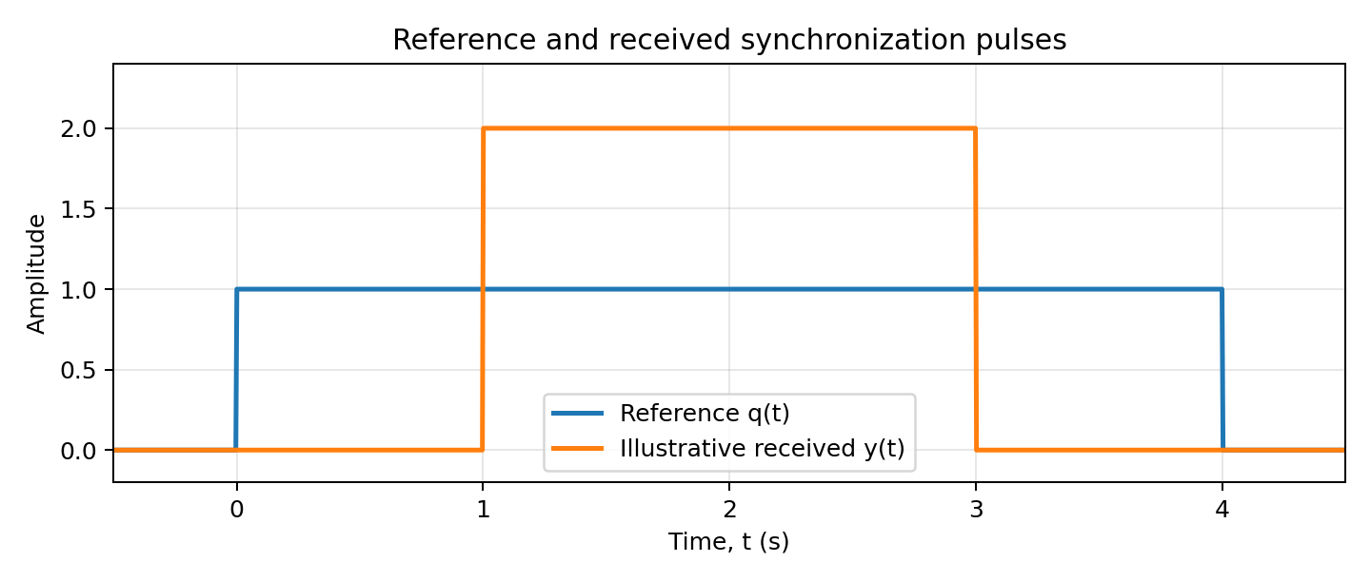
Figure 2. Pulse reconstruction illustration. The plotted example uses a=2 and t₀=1 s; the assignment data do not specify numerical values for a or t₀.
For the illustrated values a=2 and t₀=1 s, the received pulse is y(t)=2q(2(t−1)) and is non-zero from 1 s to 3 s. The general symbolic expression is the result supported by the supplied observations.

3.2 Idealized representation of the ECG events in S1
The two short events occur at t=0.4 s and t=0.9 s. An idealized impulse-train model is:
x₁(t) ≈ A₁δ(t−0.4) + A₂δ(t−0.9)
Here A₁ and A₂ represent the areas of the two practical ECG-like pulses. The question does not provide their amplitudes, durations or areas, so numerical weights cannot be determined. The impulse model identifies the event instants without inventing missing measurements.

3.3 Simplification of the emergency trigger S5
Given:
x₅(t) = 6δ(3t−6) = 6δ(3(t−2))
Use the Dirac delta scaling identity δ(at−b)= (1/|a|)δ(t−b/a), for a≠0.
δ(3(t−2)) = (1/3)δ(t−2)
x₅(t) = 6 × (1/3)δ(t−2) = 2δ(t−2)
Therefore, the simplified impulse occurs at t=2 s and has weight 2.

3.4 When is an actual short event reasonably represented by an impulse?
An actual pulse may be approximated by an ideal impulse when its duration is much smaller than the time scale or response time of the system being studied, and when the pulse's area is the important quantity. The approximation is especially useful when the downstream system cannot resolve the detailed shape of the short event.
The approximation is not appropriate when pulse width, peak amplitude, detailed ECG morphology, or high-frequency content is important. Replacing a physical pulse by an ideal impulse can lose its exact shape, duration, peak value, rise and fall times, and other fine waveform details.

4. STAGE 3 – ENERGY AND POWER SIGNAL EVALUATION

4.1 Conceptual criteria
For a continuous-time signal x(t), its energy and average power are defined by:
E = ∫₋∞⁺∞ |x(t)|² dt
P = lim(T→∞) [1/(2T)] ∫₋Tᵀ |x(t)|² dt
For a discrete-time sequence x[n], energy is E=Σₙ₌₋∞⁺∞|x[n]|² and average power is P=lim(N→∞)[1/(2N+1)]Σₙ₌₋Nᴺ|x[n]|². A non-zero finite-energy signal has zero average power. A periodic signal with finite non-zero average power has infinite total energy.

4.2 S2 – Wireless carrier
The carrier is x₂(t)=4cos(2π·2.4×10⁹t) V across a 1 Ω reference load. A sustained sinusoid is a power signal. Its average power across resistance R is A²/(2R).
P₂ = 4²/(2×1) = 8 W
Its total energy over an infinite time interval is infinite because it continues indefinitely with non-zero average power. Therefore, average power is the appropriate measure, not total energy.

4.3 S3 – IoT proximity sensor
The signal is x₃(t)=5e^(−3t)u(t). Its energy is:
E₃ = ∫₀∞ |5e^(−3t)|² dt = 25∫₀∞e^(−6t)dt
E₃ = 25[−e^(−6t)/6]₀∞ = 25/6 ≈ 4.167
Thus, S3 is a finite-energy signal. Since it ydecays to zero and has finite energy, its average power over an infinite observation interval is zero. The problem does not specify a physical load for S3, so the result is expressed in squared-amplitude seconds rather than watts.

4.4 S4 – Digital logger sequence
The sequence is x₄[n]=(0.6)ⁿu[n]. Its energy is a geometric series:
E₄ = Σₙ₌₀∞ (0.6)²ⁿ = Σₙ₌₀∞ (0.36)ⁿ
E₄ = 1/(1−0.36) = 1/0.64 = 1.5625
The sequence has finite energy and zero average power. It is therefore an energy sequence. Average power is not the useful measure because the sequence decays and its total squared sum is finite.
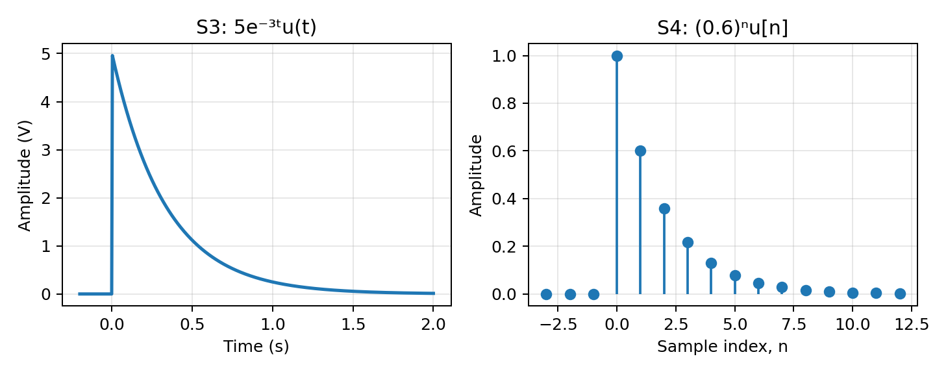
Figure 3. Continuous-time exponential S3 and discrete-time geometric sequence S4.

4.5 S1 – Ideal impulse versus practical ECG event
An ideal Dirac impulse is a generalized signal. The ordinary energy expression involves squaring δ(t), which is not defined as an ordinary function; therefore, an ideal impulse should not be classified as a conventional finite-energy signal by directly substituting it into the energy integral. A practical finite-duration ECG pulse with bounded amplitude and finite duration has finite energy. If it is non-periodic and observed over an infinite time axis, its average power is zero.

4.6 Effect of a faster decay in S3
Assume the manufacturer changes the decay rate from 3 to k, where k>3, while keeping the initial amplitude equal to 5 V. The replacement is x(t)=5e^(−kt)u(t). Before calculating, a larger decay rate means the signal falls more quickly and remains significant for a shorter time; therefore, its energy is expected to decrease.
E(k) = ∫₀∞25e^(−2kt)dt = 25/(2k)
For k>3: E(k)=25/(2k) < 25/6 = E₃
The faster-decaying replacement reduces signal energy under the stated model. From an IoT signal-energy budget perspective, this is advantageous if the useful detection information remains available long enough for reliable sensing and processing. However, a faster decay may reduce the time available to detect or measure an obstacle response. The energy saving must therefore be balanced against sensing reliability and detection requirements.
Signal | Energy / power result | Classification | Appropriate measure
S2 | P=8 W; E is infinite over infinite time. | Power signal | Average power
S3 | E=25/6; P=0. | Energy signal | Energy
S4 | E=1.5625; P=0. | Energy sequence | Energy
S1 idealized | Impulse energy is not an ordinary finite value; δ² is not defined conventionally. | Generalized impulse model | Impulse area / event timing
S1 practical | Finite energy for a bounded, finite-duration ECG event; average power 0 if aperiodic. | Practical energy signal | Energy and waveform features

5. STAGE 4 – EVALUATE THE PROCESSING BLOCKS
A system maps an input signal to an output signal. The candidate blocks must be checked against causality, time-invariance, linearity and bounded-input bounded-output (BIBO) stability. Real-time operation requires that an output at time t can be produced using information available at or before t.

5.1 R1 – Sensor smoother
R1: y[n] = 0.5x[n] + 0.5x[n−1]
- Causality: Causal. It uses the present sample x[n] and the previous sample x[n−1], not future samples.
- Time-invariance: Time-invariant. Shifting the input sequence by n₀ shifts the output by the same n₀.
- Linearity: Linear. It is a weighted sum of input samples and satisfies additivity and homogeneity.
- BIBO stability: Stable. If |x[n]|≤M, then |y[n]|≤0.5M+0.5M=M.
Conclusion: R1 is suitable for sequential real-time smoothing, assuming the sample timing and implementation are appropriate.

5.2 R2 – Predictive controller
R2: y(t) = x(t+1) − x(t)
- Causality: Non-causal. At time t, the block requires x(t+1), a future input value that is not yet available.
- Time-invariance: Time-invariant. For a shifted input x(t−t₀), the output is x(t+1−t₀)−x(t−t₀), which equals the original output shifted by t₀.
- Linearity: Linear. The difference of two shifted versions of the input preserves superposition.
- BIBO stability: Stable. If |x(t)|≤M, then |y(t)|≤|x(t+1)|+|x(t)|≤2M.
Conclusion: Although R2 is linear, time-invariant and BIBO stable, it is non-causal. It cannot be implemented as a strict real-time block when future samples are unavailable.

5.3 R3 – Position-dependent gain
R3: y(t) = cos(t)x(t)
- Causality: Causal. The output at t depends only on the input at the same time t.
- Time-invariance: Time-varying. The multiplier cos(t) changes with absolute time. Shifting the input does not simply shift the output because the gain remains tied to the original time variable.
- Linearity: Linear. For inputs x₁ and x₂ and constants a and b, the output for ax₁+bx₂ equals a cos(t)x₁(t)+b cos(t)x₂(t).
- BIBO stability: Stable. Since |cos(t)|≤1, a bounded input |x(t)|≤M produces |y(t)|≤M.
Conclusion: R3 is causal, linear and stable, but time-varying. The same input pattern applied at different absolute times can produce different outputs.

5.4 R4 – Signal combining stage
R4: y(t) = 2x(t) + 3
- Causality: Causal. The output depends only on the current input.
- Time-invariance: Time-invariant. A shift of the input shifts the output by the same amount; the constant offset remains 3.
- Linearity: Not linear. For zero input, the output is y(t)=3 rather than zero. The constant offset violates the zero-input condition and superposition.
- BIBO stability: Stable. If |x(t)|≤M, then |y(t)|≤2M+3, which is bounded.
Conclusion: R4 is causal, time-invariant and BIBO stable, but it is an affine (not linear) system because of the added constant 3.

5.5 System-property evaluation table
Block | Causal? | Time-invariant? | Linear? | BIBO stable? | Real-time observation
R1 | Yes | Yes | Yes | Yes | Suitable for sequential processing.
R2 | No | Yes | Yes | Yes | Not suitable: needs future input x(t+1).
R3 | Yes | No | Yes | Yes | Can run causally, but its gain varies with absolute time.
R4 | Yes | Yes | No | Yes | Can run causally; constant offset means it is not linear.

5.6 Mathematical checks and counterexamples
Causality check for R2: Consider two inputs that are identical up to time t but have different values at t+1. R2 produces different outputs at time t because it uses x(t+1). Therefore, its output at t cannot be determined from present and past input alone.
Time-invariance check for R3: Let the original output be y(t)=cos(t)x(t). If the input is delayed by t₀, the system output becomes cos(t)x(t−t₀). A delayed version of the original output would be y(t−t₀)=cos(t−t₀)x(t−t₀). These are generally unequal, so R3 is time-varying.
Linearity check for R4: For x(t)=0, R4 gives y(t)=3. A linear system must produce zero output for zero input. Hence R4 is not linear.
Stability check: For bounded input |x|≤M, R1 has output bound M, R2 has output bound 2M, R3 has output bound M, and R4 has output bound 2M+3. Each output is bounded whenever the input is bounded, so all four blocks are BIBO stable.

6. FINAL ENGINEERING DECISION AND REDESIGN

6.1 Deployment decision
DECISION: NO – the proposed chain R2 → R3 → R1 → R4 should not be deployed in its present form for a strict real-time controller.
The decision is based on the following evidence:
- R2 is non-causal because it requires the future value x(t+1). This conflicts directly with the field condition that future samples are unavailable.
- R3 is time-varying because its gain is cos(t). The same sensor pattern may produce different outputs when it occurs at different absolute times.
- R4 is not linear because it adds a constant offset of 3. This can introduce a baseline output even when the input is zero.
- All four blocks are individually BIBO stable, but stability alone does not make the chain suitable for reliable real-time operation.
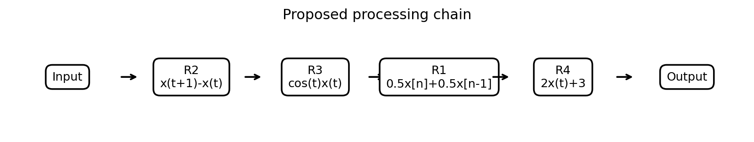
Figure 4. Proposed processing chain supplied in the assignment.

6.2 Small redesign to meet real-time and standard system-property requirements
A compact redesign is to modify only the blocks that fail the desired causal, time-invariant and linear requirements. R1 is retained because it already satisfies all four properties.
Original block | Redesigned block | Reason for modification
R2: y(t)=x(t+1)−x(t) | R2′: y(t)=x(t)−x(t−1) | Uses present and past input only; removes the future-sample requirement.
R3: y(t)=cos(t)x(t) | R3′: y(t)=g x(t), where g is a fixed constant | A fixed gain is time-invariant; it remains causal, linear and stable.
R1: y[n]=0.5x[n]+0.5x[n−1] | Retain R1 | Already causal, time-invariant, linear and BIBO stable.
R4: y(t)=2x(t)+3 | R4′: y(t)=2x(t) | Removing the constant offset restores linearity.

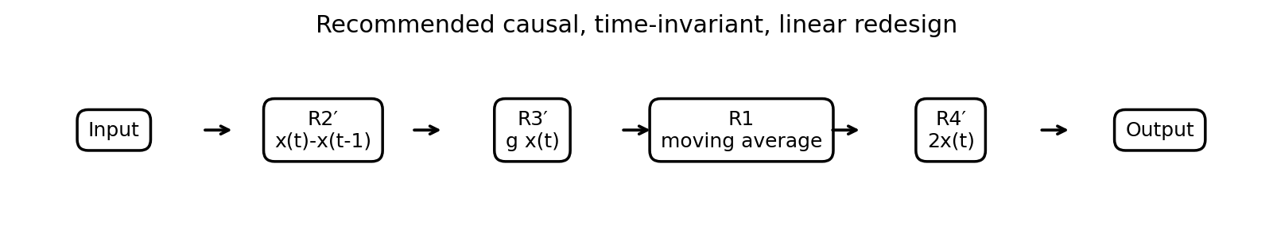
Figure 5. Recommended redesigned chain. The fixed gain g may be selected according to the sensor calibration requirements.

6.3 Properties of the redesigned blocks
- R2′ is causal because it uses x(t) and x(t−1), time-invariant because its delay is fixed, linear because it is a difference of input samples, and BIBO stable because |y(t)|≤2M for |x(t)|≤M.
- R3′ is causal, time-invariant and linear. It is BIBO stable for any finite fixed gain g because |y(t)|≤|g|M.
- R1 remains causal, time-invariant, linear and BIBO stable as established in Stage 4.
- R4′ is causal, time-invariant and linear. It is BIBO stable because |2x(t)|≤2M for bounded input.
A cascade of causal systems is causal. A cascade of time-invariant systems is time-invariant, and a cascade of linear systems is linear. A cascade of BIBO-stable blocks is BIBO stable. Therefore, the redesigned chain has the desired standard properties, provided the blocks are implemented with consistent sampling and timing.

6.4 Effect of redesign on reliability
Requirement | Effect of redesign
Causality | The future-sample dependency is removed, so each output can be computed from available present and past data.
Time-invariance | Replacing the time-varying cosine gain with a fixed gain makes the processing behaviour independent of absolute start time.
Linearity | Removing the additive constant from R4 restores the superposition property.
Stability | Each redesigned block remains BIBO stable; bounded sensor signals produce bounded outputs.
Real-time suitability | The redesigned operations can be implemented sequentially without waiting for future samples.
System reliability | Predictable behaviour, bounded outputs and consistent response to shifted inputs support more dependable controller operation.

Engineering implementation note: the assignment does not specify the sampling interval, controller hardware, processing latency, sensor calibration limits or safety thresholds. These must be established and tested before an actual vehicle is deployed. The redesign establishes suitable mathematical system properties; it does not by itself certify the complete vehicle as safe.

7. CONCLUSION
The signal observations were classified using continuous-time and discrete-time descriptions, periodicity, signal shape and energy/power behaviour. S3 and S4 were represented using unit-step-gated decaying signals, S5 was simplified to 2δ(t−2), S6 was expressed as the difference of two ramps, and S7 was reconstructed using amplitude scaling, time compression and delay.
The wireless sinusoid S2 is a power signal with an average power of 8 W across the stated 1 Ω load. S3 and S4 are energy signals with energies 25/6 and 1.5625 respectively. A faster decay rate for S3 reduces its energy, although the sensor's detection performance must remain acceptable.
The original chain is not recommended for strict real-time deployment because R2 is non-causal, R3 is time-varying and R4 is non-linear. Replacing these three blocks with a causal difference, fixed gain and zero-offset gain stage produces a chain that is causal, time-invariant, linear and BIBO stable. The proposed redesign is therefore the more appropriate mathematical structure for a reliable real-time controller, subject to hardware and safety validation.

8. FORMULA SUMMARY
Item | Result / formula
S3 | x₃(t)=5e^(−3t)u(t); E₃=25/6≈4.167.
S4 | x₄[n]=(0.6)ⁿu[n]; E₄=1/(1−0.36)=1.5625.
S5 | 6δ(3t−6)=2δ(t−2).
S6 | x₆(t)=m[r(t)−r(t−T)]=mtu(t)−m(t−T)u(t−T).
S7 | y(t)=2q(a(t−t₀))=2[u(a(t−t₀))−u(a(t−t₀)−4)], a>1, t₀>0.
S2 average power | P₂=A²/(2R)=4²/(2×1)=8 W.
Faster S3 decay | For x(t)=5e^(−kt)u(t), E(k)=25/(2k); k>3 gives lower energy.
R1 bound | |y[n]|≤M if |x[n]|≤M.
R2 bound | |y(t)|≤2M if |x(t)|≤M, but the block is non-causal.
R3 bound | |y(t)|≤M because |cos(t)|≤1.
R4 bound | |y(t)|≤2M+3; affine, not linear.

